**FEED THE NEED - FOOD DONATION APPLICATION**

**A MINI-PROJECT REPORT**

***Submitted by***

**SAKTHILAKSHMI M 2116210701223**

***in partial fulfillment of the award of the degree***

***of***

**BACHELOR OF ENGINEERING**

**IN**

**COMPUTER SCIENCE AND ENGINEERING**



**RAJALAKSHMI ENGINEERING COLLEGE, THANDALAM (AUTONOMOUS)**

**MAY 2023**

**BONAFIDE CERTIFICATE**

Certified that this mini project **“FEED THE NEED - FOOD DONATION APPLICATION”** is the bonafide work of **"Sakthilakshmi M (2116210701223)”** who carried out the mini project work under my supervision.

|  |  |
| --- | --- |
|  | **SIGNATURE** |
|  | **Mrs. R AKILADEVI, M.E.,**  **Assistant Professor(SS)**  Computer Science and Engineering, |
|  |
|  |
|  | Rajalakshmi Engineering College(Autonomous),  Thandalam, Chennai - 602105. |

This mini project report is submitted for the end semester practical viva voce examination to be held on __________

**INTERNAL EXAMINER** **EXTERNAL EXAMINER**

**ACKNOWLEDGEMENT**

I express my sincere thanks to our beloved and honorable chairman **MR.S.MEGANATHAN** and the chairperson **DR. M.THANGAM MEGANATHAN** for their timely support and encouragement. I am greatly indebted to our respected and honorable principal **Dr. S.N. MURUGESAN** for his able support and guidance.

No words of gratitude will suffice for the unquestioning support extended to me by my Head of The Department **Dr. P. KUMAR M.E Ph.D.,**  for being ever supporting force during my project work.

I also extend my sincere and hearty thanks to my internal guide **Mrs.R.AKILADEVI M.E,** for her valuable guidance and motivation during the completion of this mini project.

My sincere thanks to my family members, friends and other staff members of computer science engineering.

## TABLE OF CONTENT

**S.No TITLE Pg.No**

ABSTRACT  8

1. INTRODUCTION

1.1 INTRODUCTION 9

1.2 SCOPE OF THE WORK  9

1.3 PROBLEM STATEMENT 9

1.4 AIM AND OBJECTIVES OF THE PROJECT 10

2. SYSTEM SPECIFICATIONS 11

2.1 HARDWARE SPECIFICATIONS 11

2.2 SOFTWARE SPECIFICATIONS 11

3. MODULE DESCRIPTION 12

4. SYSTEM DESIGN 1 4

4.1 ARCHITECTURE DIAGRAM 14

5. COLLECTIONS 15

5.1 USER DETAILS 15

5.2 DONOR DETAILS 16

5.3 RECEIVER DETAILS 17

5.4 FOOD DETAILS 17

5.5 IMAGES 17

6. SAMPLE CODING 18

7. SCREEN SHOTS 28

8. CONCLUSION AND FUTURE ENHANCEMENT 32

**REFERENCES**

**LIST OF FIGURES**

|  |  |  |
| --- | --- | --- |
| **FIGURE NO** | **FIGURE NAME** | **PAGE NO.** |
| 1 | ARCHITECTURE DIAGRAM | 14 |
| 2 | HOME PAGE | 28 |
| 3.A 3.B | REGISTER AND LOGIN PAGE | 28 |
| 4.A 4.B | DONATE PAGE | 29 |
| 5.A 5.B | DONOR PAGE | 29 |
| 6.A 6.B | RECEIVER PAGE | 29 |
| 7 | DONOR DETAILS PAGE | 30 |
| 8 | FOOD ORDER PAGE | 30 |
| 9 | CONFIRMATION PAGE | 31 |

**LIST OF COLLECTIONS**

|  |  |  |
| --- | --- | --- |
| **TABLE NO.** | **TITLE** | **PAGE NO.** |
| 1 | USER DETAILS | 15 |
| 2 | DONOR DETAILS | 16 |
| 3 | RECEIVER DETAILS | 17 |
| 4 | FOOD DETAILS | 17 |
| 5 | IMAGES | 17 |

## LIST OF ABBREVIATION

|  |  |
| --- | --- |
| **ABBREVIATION** | **ACRONYM** |
| **SRS** | Software Requirement Specification |
| **CLIENT/SERVER** | The entity who will be using the interview feedback system. |
| **SERVER** | A system that runs in Linux |
| **RAM** | Random access memory |
| **PHP** | Hypertext Pre-processor. |
| **MYSQL** | A relational database management system |
| **HTTP** | Hyper Text Transfer Protocol |
| **PDF** | Portable Document Format |
| **Username** | Unique name given to each account of digital library |
| **Password** | Unique word set by each user as a secret |

code.

**ABSTRACT**

An estimated amount of 1.3 billion tonnes of food is wasted annually. At the same time, there are over 2 billion people around the worldexperiencing hunger or lack of access to nutritious or sufficient food. Weshould not waste food because other people are dying from hunger.Wasting food is such an irresponsible act of mankind. Wastage of foodoccurs mostly in restaurants, in various celebrations done by thepeople,etc. We are wasting food because we don’t know where to donate. Itis very difficult for us to search for needy people nearby our location and itis also a tiresome job. So we are dumping the food in the garbage.This food donation application focuses on the reachability of foodto needy people. The needy people can register in this application and theycan update their location and contact number. Similarly, the restaurants andthose people who are willing to donate can register in this application andupdate their location. Once there is availability of food, the location ofavailability and the donor’s contact address will be shared via message tothe needy people. So the needy people can go and collect the food from thedonor.

So this application will be very useful to the people who need food and it also prevents the wastage of the precious resource. “There is food for everyone in the planet. But somebody in the planet are lacking access to food”

**CHAPTER 1**

**1.1 INTRODUCTION**

A food donation application website is an online platform that connects food donors with organizations and individuals in need of food. The website aims to address the problem of food waste by enabling individuals and businesses to donate excess food to those who need it. The website typically provides a user-friendly interface that allows donors to easily register, post information about the food they want to donate, and connect with potential recipients. Recipients can also register on the website and search for available donations based on location, type of food, and other criteria. The food donation application website provides an efficient and convenient way to redistribute surplus food, reduce food waste, and help alleviate hunger in the community.

**1.2 SCOPE OF THE WORK**

The scope of a food donation application is typically focused on facilitating the process of food donation and distribution. The application can be designed to serve a wide range of users, including individual donors, food businesses, non-profit organizations, and food banks. The application can also cover a variety of food types, including perishable and non-perishable food items.

**1.3 PROBLEM STATEMENT**

The problem that a food donation application aims to address is the issue of food waste and food insecurity. In many developed countries, a significant amount of food is wasted every day due to various reasons such as overproduction, expiration, and surplus. At the same time, many individuals and families struggle with food insecurity and lack access to nutritious food.

The problem with the traditional methods of food donation is that they are often time-consuming, inefficient, and lack transparency. Donors may not be aware of the most effective way to donate their excess food, and recipients may not know where to look for donations. This can lead to a lot of food waste and missed opportunities for those in need.

A food donation application aims to solve these problems by providing an easy-to-use platform that connects food donors with organizations and individuals in need of food. The application can streamline the donation process, making it more efficient, transparent, and accessible for everyone. By reducing food waste and ensuring that surplus food goes to those who need it, a food donation application can have a positive impact on the environment and the community.

Top of Form

Bottom of Form

**1.4 AIM AND OBJECTIVES OF THE PROJECT**

The aim of a food donation application is to reduce food waste and address food insecurity by connecting donors with organizations and individuals in need of food. The application aims to make the process of food donation more efficient, transparent, and accessible for everyone.

The application aims to provide an easy-to-use platform that simplifies the process of food donation for donors and recipients.

**CHAPTER 2**

**SYSTEM SPECIFICATIONS**

**2.1 HARDWARE SPECIFICATIONS**

|  |  |  |
| --- | --- | --- |
| Processor | **:** | Intel i5 |
| Memory Size | **:** | 8GB (Minimum) |
| HDD | **:** | 1 TB (Minimum) |

**2.2 SOFTWARE SPECIFICATIONS**

|  |  |  |
| --- | --- | --- |
| Operating System | **:** | WINDOWS 10 |
| Front – End | **:** | HTML,CSS,JAVASCRIPT |
| Back - End | **:** | PHP, MYSQL |
| Language | **:** | PHP,SQL,JS |
|  |  |  |
|  |  |  |

**CHAPTER 3**

**MODULE DESCRIPTION**

**USER REGISTRATION AND LOGIN MODULE:**

The user registration and login module is a fundamental feature of a food donation application. This module allows users to create a personal account and securely log in to the application to access its features and functionalities.The users location is accessed in this module using latitude and longitude to find the distance between donors and receivers.

**DONATION MODULE:**

The donors can fill their details, food items they want to donate and their quantity in this page. After this donation is made, a mail which shows the details of the donor will be sent to the receivers who are at distance less than or equal to 11 kilometres.

**DONOR MODULE:**

This module shows the donors who are at the distance less than or equal to 11 kilometres to the receiver. The distance is calculated based on the latitude and longitude of the donor and receiver. If the donor is not in this particular distance, he/she will not be visible to that receiver.

**DONOR DETAILS MODULE:**

This module shows the details of the donor like address, mobile number, food items they provide and their quantity.

**ORDER MODULE:**

This module facilitates the receiver to order the food items provided by the donor. They can specify the quantity and items they want and place the order.

**CONFIRMATION MODULE:**

In this module, receiver's order will be confirmed and OTP will be provided to both donor and receiver for the unique identification and the receiver's details will be sent to the donor.

**CHAPTER 4**

**SYSTEM DESIGN**

**4.1 ARCHITECTURE DIAGRAM**

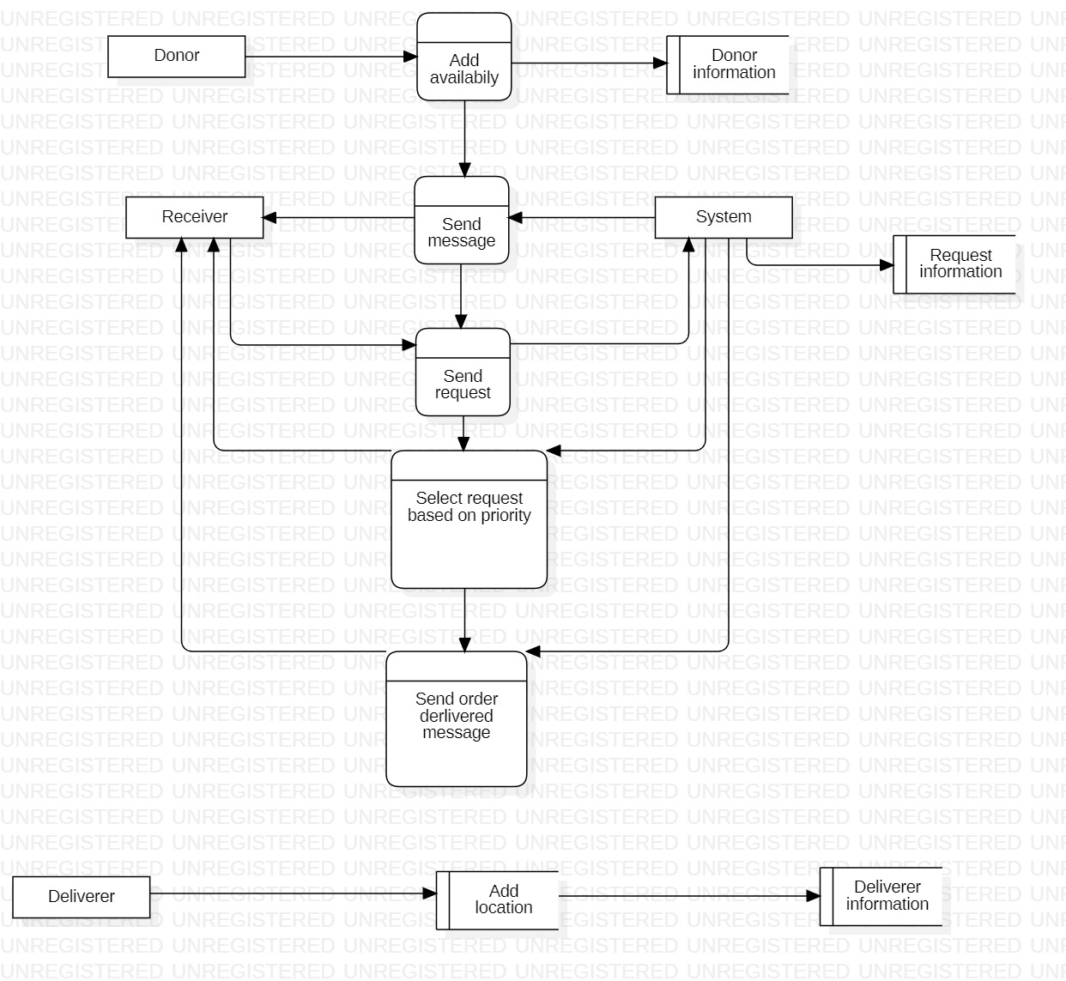

**CHAPTER - 5**

**COLLECTIONS**

**5.1 USER DETAILS**

|  |  |  |
| --- | --- | --- |
| **SL.NO** | **ATTRIBUTE** | **TYPE** |
| 1. | USERNAME | VARCHAR |
| 2. | EMAIL | VARCHAR |
| 3. | PASSWORD | VARCHAR |
| 4. | CONFIRM PASSWORD | VARCHAR |
| 5. | LATITUDE | FLOAT |
| 6. | LONGITUDE | FLOAT |
| 7. | USER TYPE | VARCHAR |
| 8. | ID | INT |

**5.2 DONOR DETAILS**

|  |  |  |
| --- | --- | --- |
| **S.NO** | **ATTRIBUTE** | **TYPE** |
| 1. | DONOR NAME | VARCHAR |
| 2. | MOBILE NUMBER | VARCHAR |
| 3. | ADDRESS | VARCHAR |
| 4. | DISTRICT | VARCHAR |
| 5. | STATE | VARCHAR |
| 6. | LOCATION PICTURE | LARGE BLOB |
| 7. | FOOD ITEMS | VARCHAR |
| 8. | QUANTITY | VARCHAR |
| 9. | PREPARATION TIME | VARCHAR |
| 10. | DONOR_ID | INT |

**5.3 RECEIVER DETAILS**

|  |  |  |
| --- | --- | --- |
| **S.NO** | **ATTRIBUTE** | **TYPE** |
| 1. | RECEIVER NAME | VARCHAR |
| 2. | MOBILE NUMBER | VARCHAR |
| 3. | ADDRESS | VARCHAR |
| 4. | DISTRICT | VARCHAR |
| 5. | STATE | VARCHAR |

**5.4 FOOD DETAILS:**

|  |  |  |
| --- | --- | --- |
| **S.NO** | **ATTRIBUTE** | **TYPE** |
| 1. | DONOR_ID | VARCHAR |
| 2. | FOOD_ITEM | VARCHAR |
| 3. | QUANTITY | INT |

**5.5 ORDER DETAILS:**

|  |  |  |
| --- | --- | --- |
| **S.NO** | **ATTRIBUTE** | **TYPE** |
| 1. | DONOR_ID | VARCHAR |
| 2. | FOOD_ITEM | VARCHAR |
| 3. | QUANTITY | INT |
| 4. | RECEIVER_ID | INT |

**CHAPTER 6**

**SAMPLE CODING**

<?php

function twopoints_on_earth($latitudeFrom, $longitudeFrom,

$latitudeTo, $longitudeTo)

{

$long1 = deg2rad($longitudeFrom);

$long2 = deg2rad($longitudeTo);

$lat1 = deg2rad($latitudeFrom);

$lat2 = deg2rad($latitudeTo);

// Haversine Formula

$dlong = $long2 - $long1;

$dlati = $lat2 - $lat1;

$val = pow(sin($dlati/2), 2) + cos($lat1) * cos($lat2) * pow(sin($dlong/2), 2);

$res = 2 * asin(sqrt($val));

// radius value in kilometers

$radius = 6371;

return ($res * $radius);

}

?>

<?php include('templates/header.php');

if(!isset($_SESSION))

session_start();

$id=$_SESSION['userid'];

$sql = "SELECT * FROM user_details where id = $id";

$result = mysqli_query($conn,$sql);

$donor_details = mysqli_fetch_assoc($result);

?>

<!DOCTYPE html>

<html lang="en">

<head>

<style>

.donate-container {

background: /* linear-gradient(rgba(0,0,0,0.3),rgba(0,0,0,0.6)),*/url("images/donate.jpg");

background-size: cover;

background-repeat: no-repeat;

height: 100vh;

}

.flexbox {

display: flex;

justify-content: center;

align-items: center;

gap: 20px;

}

.donate-container h1 {

color: white;

text-align: center;

text-shadow: 0 5px 10px rgba(0,0,0);

}

.donate-box h2 {

text-align: center;

color: white;

text-shadow: 0 5px 10px rgba(0,0,0);

margin-bottom: 10px;

}

.donate-box {

position: absolute;

top: 60%;

left: 50%;

transform: translate(-50%,-50%);

border-radius: 20px;

padding: 30px;

background-color: rgba(0,0,0,0.5);

box-shadow: 7px 7px 20px #000;

}

.donate-box .input-group input {

width: 250px;

padding: 5px;

margin: 5px;

margin-left: 10px;

border-radius: 2px;

border: none;

outline: none;

}

.btn {

margin-left: 250px;

padding: 5px;

margin-top: 10px;

}

.error {

margin-left: 10px;

color: red;

}

label {

color: white;

}

.file {

width: 250px;

margin: 2px;

margin-left: 7px;

border-radius: 2px;

border: none;

outline: none;

}

::placeholder {

color: black;

}

.dialog-box-1 {

display: none;

max-width: 50ch;

position: fixed;

top: 50%;

left: 50%;

transform: translate(-50%, -50%);

border: none;

outline: none;

padding: 30px;

border-radius: 10px;

box-shadow: 0 5px 10px rgba(255,255,255,0.5);

}

.dialog-box-1 p {

text-align: center;

font-size: 20px;

color: green;

}

.dialog-box-1::backdrop {

background-color: rgba(0,0,0);

}

.dialog-box-1 button {

margin-top: 20px;

margin-left: 100px;

width: 100px;

padding: 5px;

outline: none;

border: none;

background-color: green;

color: white;

font-size: 15px;

border-radius: 10px;

}

</style>

</head>

<?php

use PHPMailer\PHPMailer\PHPMailer;

use PHPMailer\PHPMailer\SMTP;

use PHPMailer\PHPMailer\Exception;

include('config/connect.php');

$sql = "SELECT username,email,latitude,longitude FROM user_details WHERE user_type = 'receiver' ";

$result = mysqli_query($conn,$sql);

$receiverDetails = mysqli_fetch_all($result,MYSQLI_ASSOC);

$insert='';

$insertTest=0;

$name = $lpic = $phone = $address = $district = $state = $pincode = $food = $quantity = $time = '';

$errors = array('name'=>'','lpic'=>'','phone' => '','address' => '','district' => '','state'=>'','pincode'=>'','food' => '','quantity' => '','time' => '');

if(isset($_POST['submit']))

{

if(empty($_POST['dname'])) {

$errors['name'] = 'Name is required!!!';

}

else {

$name = $_POST['dname'];

if(!preg_match('/^[a-zA-Z\s]+$/', $name)){

$errors['name'] = 'Name must be letters and spaces only';

}

}

if(empty($_FILES['lpic']['name']))

{

$errors['lpic'] = 'Image is required!';

}

else if(getimagesize($_FILES['lpic']['tmp_name'])==false) {

$errors['lpic'] = "Image is required";

}

else {

$lpic = $_FILES['lpic']['tmp_name'];

$name = $_FILES['lpic']['name'];

$lpic = file_get_contents($lpic);

$lpic = base64_encode($lpic);

}

if(empty($_POST['phone'])) {

$errors['phone'] = 'Mobile number is required!!!';

}

else {

$phone = $_POST['phone'];

if (!preg_match('/^[0-9]{10}$/', $phone)) {

$errors['phone'] = 'Mobile number must contain 10 digits only';

}

}

if(empty($_POST['address'])) {

$errors['address'] = 'Address is required!!!';

}

else {

$address = $_POST['address'];

}

if(empty($_POST['district'])) {

$errors['district'] = 'District is required!!!';

}

else {

$district = $_POST['district'];

if(!preg_match('/^[a-zA-Z\s]+$/', $district)){

$errors['district'] = 'District must be letters and spaces only';

}

}

if(empty($_POST['state'])) {

$errors['state'] = 'State is required!!!';

}

else {

$state = $_POST['state'];

if(!preg_match('/^[a-zA-Z\s]+$/', $state)){

$errors['state'] = 'Name must be letters and spaces only';

}

}

if(empty($_POST['pincode'])) {

$errors['pincode'] = 'Pincode is required!!!';

}

else {

$pincode = $_POST['pincode'];

if (!preg_match('/^[0-9]+$/', $pincode)) {

$errors['pincode'] = 'Pincode must contain only numbers!';

}

}

if(empty($_POST['food'])) {

$errors['food'] = 'Food is required!!!';

}

else {

$food = $_POST['food'];

}

if(empty($_POST['quantity'])) {

$errors['quantity'] = 'Quantity is required!!!';

}

else {

$quantity = $_POST['quantity'];

}

if(empty($_POST['time'])) {

$errors['time'] = 'Time is required!!!';

}

else {

$time = $_POST['time'];

}

if (array_filter($errors))

{

}

else {

$name = mysqli_real_escape_string($conn, $_POST['dname']);

$phone = mysqli_real_escape_string($conn, $_POST['phone']);

$address = mysqli_real_escape_string($conn, $_POST['address']);

$state = mysqli_real_escape_string($conn, $_POST['state']);

$pincode = mysqli_real_escape_string($conn, $_POST['pincode']);

$district = mysqli_real_escape_string($conn, $_POST['district']);

$food = mysqli_real_escape_string($conn, $_POST['food']);//explode(',',$_POST['food']);

$quantity = mysqli_real_escape_string($conn, $_POST['quantity']);//explode(',',$_POST['quantity']);

$time = mysqli_real_escape_string($conn, $_POST['time']);

$id = $_SESSION['userid'];

$insert = "INSERT INTO donor(donor_name,picture,phone,address,district,state,pincode,food,quantity,time,id) VALUES('$name','$lpic','$phone','$address','$district','$state','$pincode','$food','$quantity','$time','$id')";

// foreach($food as $key=>$fooditem) {

// $quantityitem = $quantity[$key];

// $insert = "INSERT INTO donor(donor_name,picture,phone,address,district,state,pincode,food,quantity,time) VALUES('$name','$lpic','$phone','$address','$district','$state','$pincode','$fooditem','$quantityitem','$time')";

$insertTest = mysqli_query($conn,$insert);

}

}

if($insertTest) {

if(isset($_SESSION) && $_SESSION['userType']=='donor') {

$sql = "SELECT latitude,longitude FROM user_details WHERE id = '$id' ";

$result = mysqli_query($conn,$sql);

$donorDetails = mysqli_fetch_all($result,MYSQLI_ASSOC);

$donorLatitude = $donorDetails[0]['latitude'];

$donorLongitude = $donorDetails[0]['longitude'];

foreach($receiverDetails as $receiverDetail) {

$receiverLatitude = $receiverDetail['latitude'];

$receiverLongitude = $receiverDetail['longitude'];

$distance = twopoints_on_earth($donorLatitude, $donorLongitude, $receiverLatitude, $receiverLongitude).' '.'kilometers';

if($distance <= 12) {

if(!class_exists('PHPMailer\PHPMailer\Exception'))

{

require 'PHPMailer/src/Exception.php';

require 'PHPMailer/src/PHPMailer.php';

require 'PHPMailer/src/SMTP.php';

}

$mail = new PHPMailer(true);

try {

$mail->isSMTP();

$mail->Host = 'smtp.gmail.com';

$mail->SMTPAuth = true;

$mail->Username = 'donorftn@gmail.com';

$mail->Password = 'lqygfnkacrerpymd';

$mail->SMTPSecure = PHPMailer::ENCRYPTION_SMTPS;

$mail->Port = 465;

$mail->setFrom('from@example.com', 'Feed The Need');

$mail->addAddress($receiverDetail['email']); //Add a recipient

$message = "Dear ".$receiverDetail['username'].",<br>

I hope this email finds you well. I am writing to inform you that ".$name." has expressed their interest in donating ".$food." to your organization.

We want to help you. So, you can order the food via Feed The Need website.<br><br><br>

Regards,<br>

Sakthilakshmi M,<br>

Social Activist.<br>

"; $mail->isHTML(true);

$mail->Subject = $name.' wants to donate!';

$mail->Body = $message;

$mail->AltBody = 'This is the body in plain text for non-HTML mail clients';

$mail->send();

} catch (Exception $e) {

echo "Message could not be sent. Mailer Error: {$mail->ErrorInfo}";

}

}

}

}

}

if($insertTest) {

$sql = "SELECT donor_id FROM donor WHERE id = '$id' ";

$result = mysqli_query($conn,$sql);

$donorID = mysqli_fetch_all($result,MYSQLI_ASSOC);

$d_id = $donorID[0]['donor_id'];

$food = explode(',',$_POST['food']);

$quantity = explode(',',$_POST['quantity']);

foreach($food as $key=>$fooditem) {

$quantityitem = $quantity[$key];

$insert = "INSERT INTO food(donor_id,food_item,quantity) VALUES('$d_id','$fooditem','$quantityitem')";

if(mysqli_query($conn,$insert))

{

$insertTest = true;

}

}

}

?>

<div class="donate-container">

<h1>Alone we can do so little!

Together we can do so much!</h1>

<div class="donate-box">

<h2>DONATE</h2>

<form action="donate.php" method="POST" enctype="multipart/form-data" >

<div class="flexbox">

<div class="box1">

<div class="input-group">

<input type = "text" name="dname" id="dname" placeholder="Name" value="<?php echo $donor_details['username']; ?>" readonly>

<div class="error"><?php echo $errors['name'] ?></div>

</div>

<div class="input-group">

<input type = "text" name="phone" id="phone" placeholder="Mobile Number" autocomplete="off">

<div class="error"><?php echo $errors['phone'] ?></div>

</div>

<div class="input-group">

<input type = "text" name="address" id="address" placeholder="Address" autocomplete="off">

<div class="error"><?php echo $errors['address'] ?></div>

</div>

<div class="input-group">

<input type = "text" name="district" id="district" placeholder="District" autocomplete="off">

<div class="error"><?php echo $errors['district'] ?></div>

</div>

<div class="input-group file">

<label for="lpic">Location picture:</label>

<input type = "file" name="lpic" id="lpic">

<div class="error"><?php echo $errors['lpic'] ?></div>

</div>

</div>

<div class="box">

<div class="input-group">

<input type = "text" name="state" id="state" placeholder="State" autocomplete="off">

<div class="error"><?php echo $errors['state'] ?></div>

</div>

<div class="input-group">

<input type = "text" name="pincode" id="pincode" placeholder="Pincode" autocomplete="off">

<div class="error"><?php echo $errors['pincode'] ?></div>

</div>

<div class="input-group">

<input type = "text" name="food" id="food" placeholder="Food Items [Eg: Idli,Poori]" autocomplete="off">

<div class="error"><?php echo $errors['food'] ?></div>

</div>

<div class="input-group">

<input type = "text" name="quantity" id="quantity" placeholder="Quantity in kgs[Eg: 2,3]" autocomplete="off">

<div class="error"><?php echo $errors['quantity'] ?></div>

</div>

<div class="input-group">

<label for="time">Preparation Time: </label>

<input type = "datetime-local" name="time" id="time">

<div class="error"><?php echo $errors['time'] ?></div>

</div>

</div>

</div>

<input type="submit" name="submit" id="don" value="Submit" class="btn">

</form>

</div>

</div>

<dialog class="dialog-box-1">

<img src="images/success.gif" alt="" width="300px" height = "300px">

<p>Thank you for donating!</p>

<a href="index.php"><button class="close" onclick=closebtn() >Ok</button></a>

</dialog>

<?php

if($insertTest)

{

echo "<script>

document.querySelector('.dialog-box-1').style.display = 'block';

</script>";

}

?>

<?php include('templates/footer.php'); ?>

**CHAPTER-7**

**SCREENSHOTS**

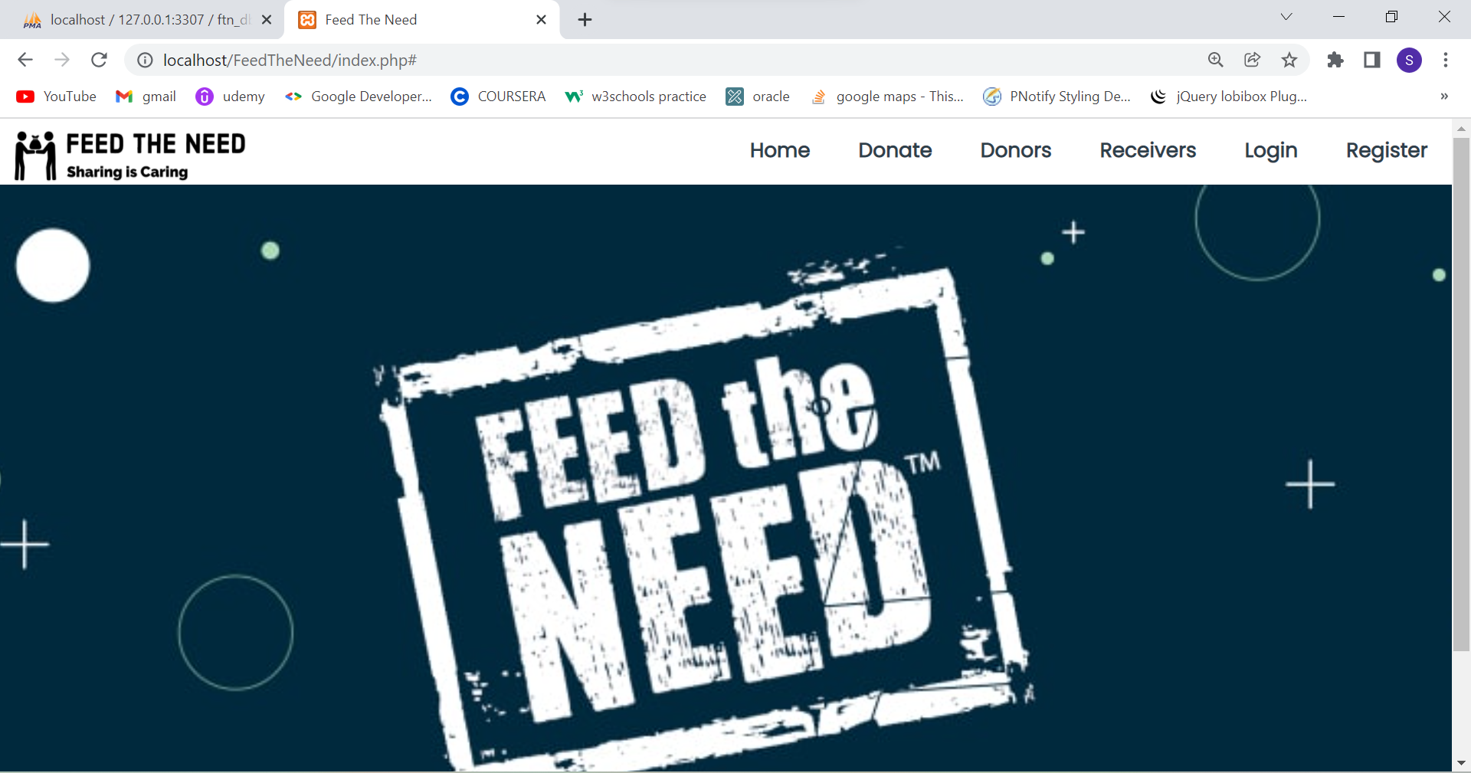**Fig.6.1 HOME -** This is the home page of food donation website.

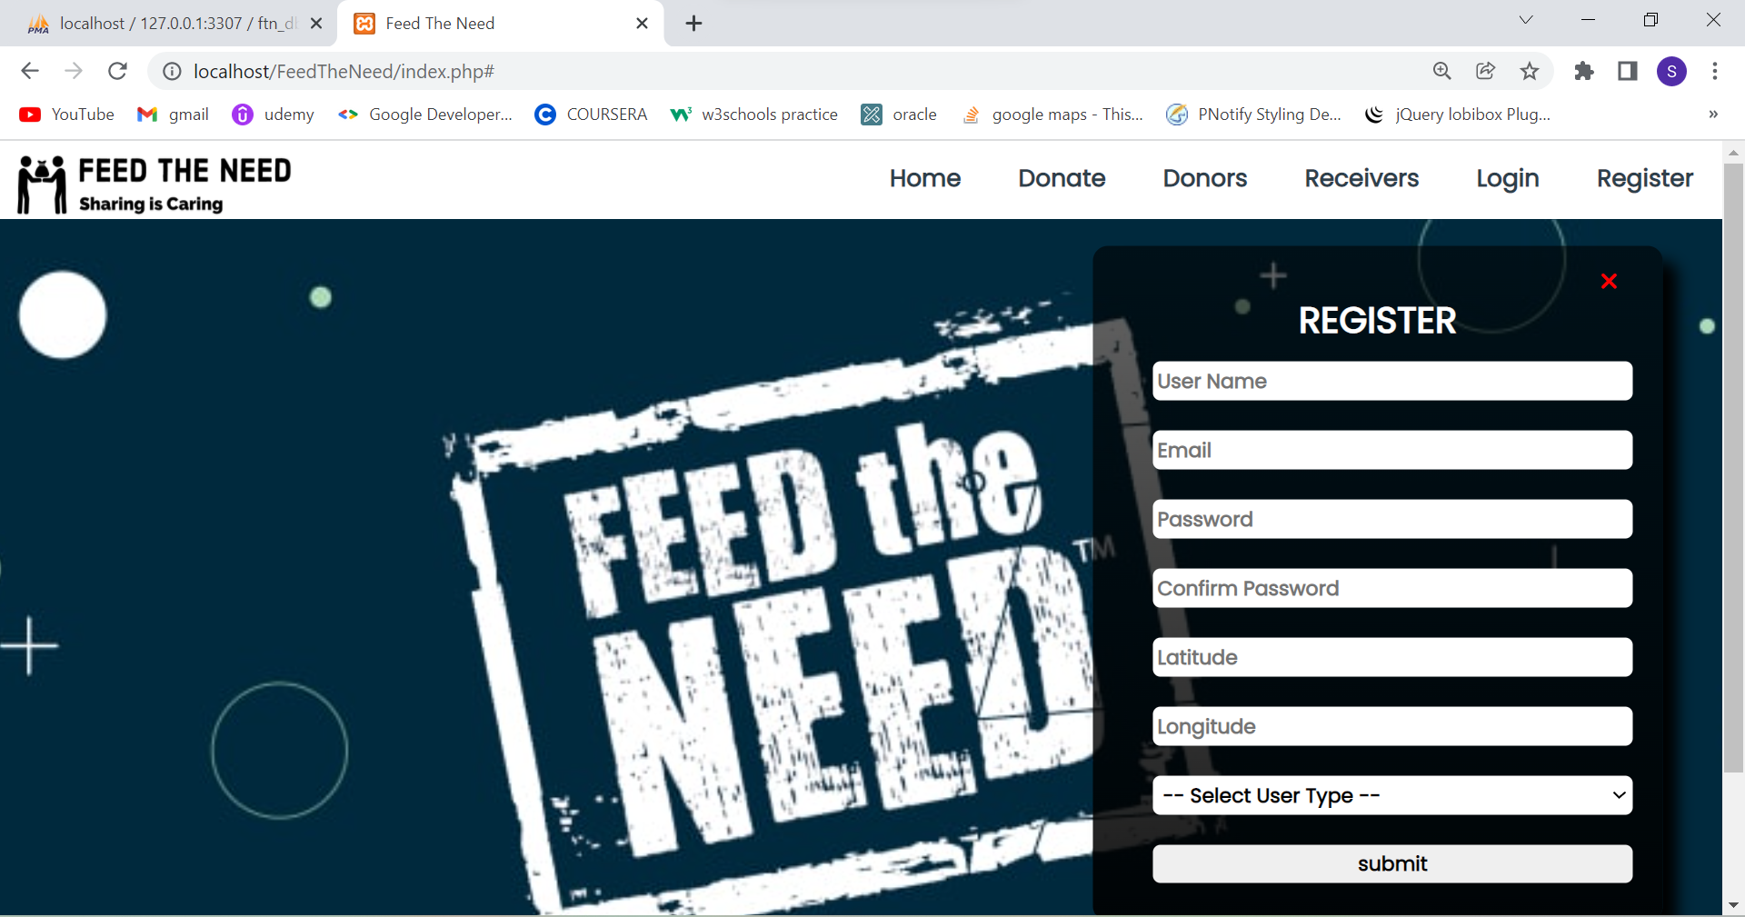

**Fig.6.2 REGISTRATION PAGE -** In this page, the user can enter their details such as username, email, password, latitude, longitude and user type and enter into this website.

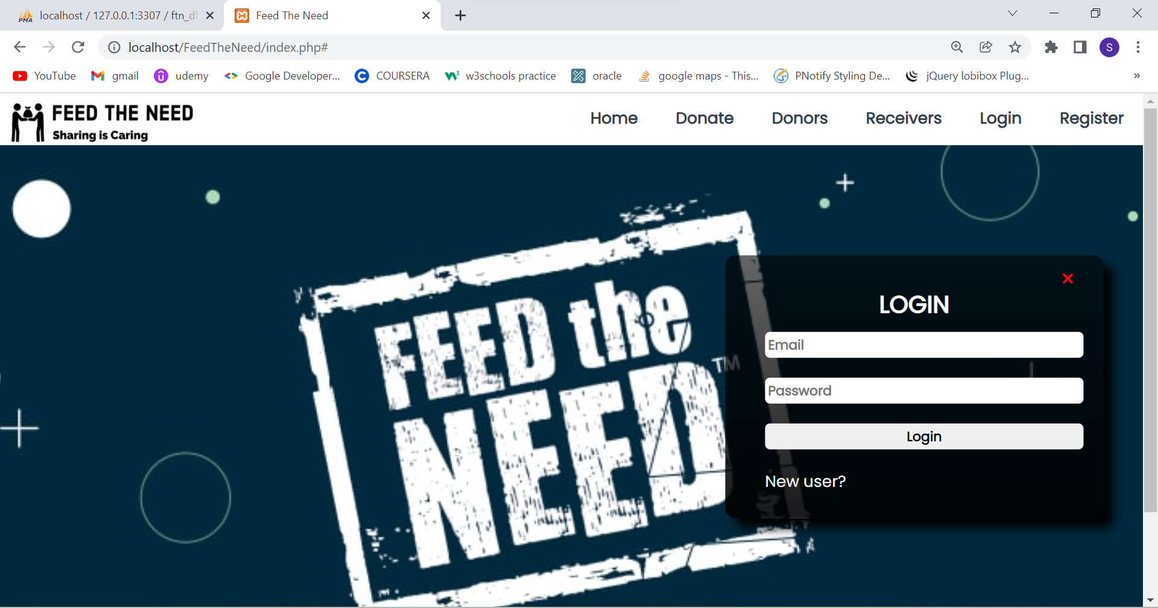

**Fig.6.3 LOGIN PAGE -** This page is used to log-in into the website. After logging in, the user interface will change according to the user.

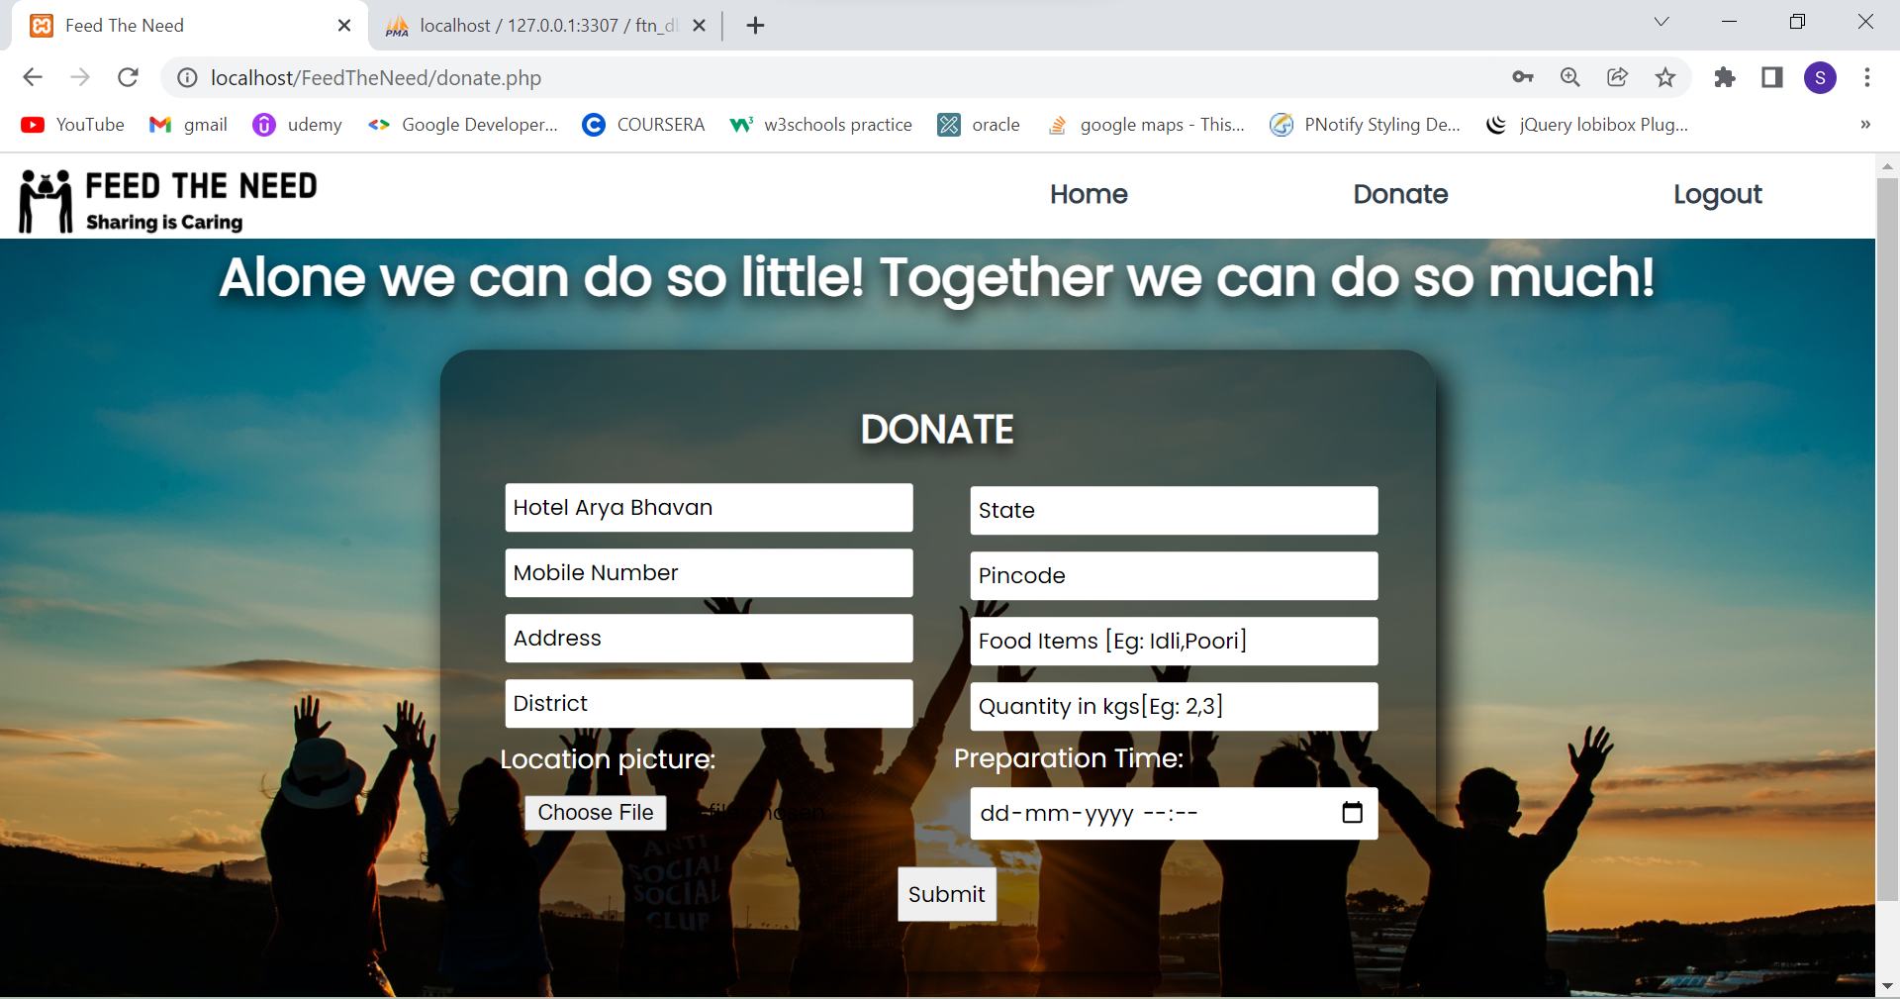

**Fig 6.4 DONATION PAGE -** The donor enters their details, food details and their quantity. After filling this form, the details of the donor will be sent to the receivers who are at a distance less than or equal to 11 kilometres in e-mail.

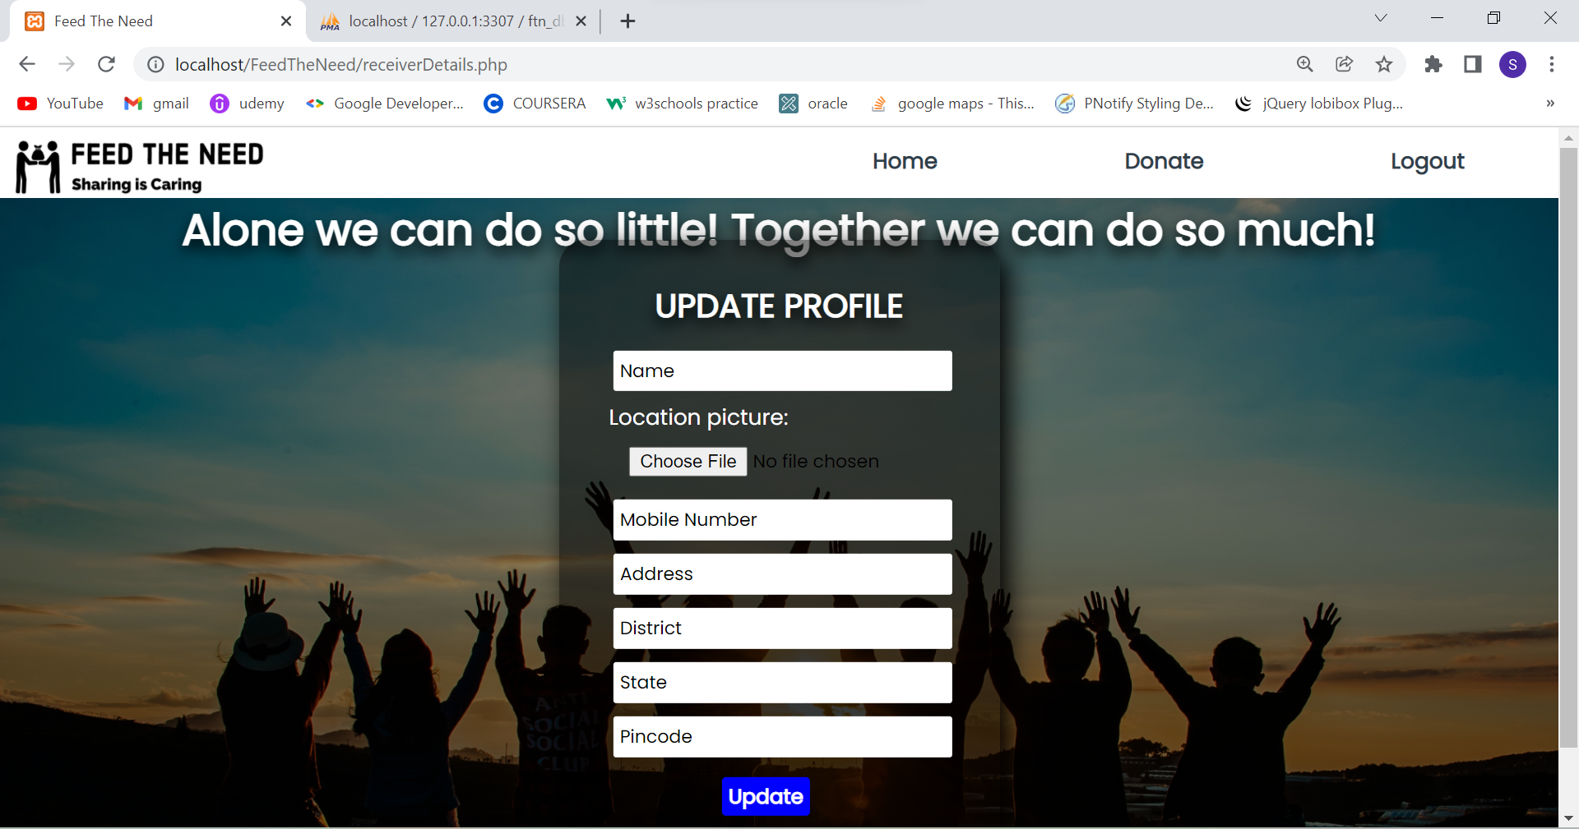

**Fig 6.5 RECEIVER DETAILS PAGE -** The details of the receiver will be collected in this page and stored in the database.

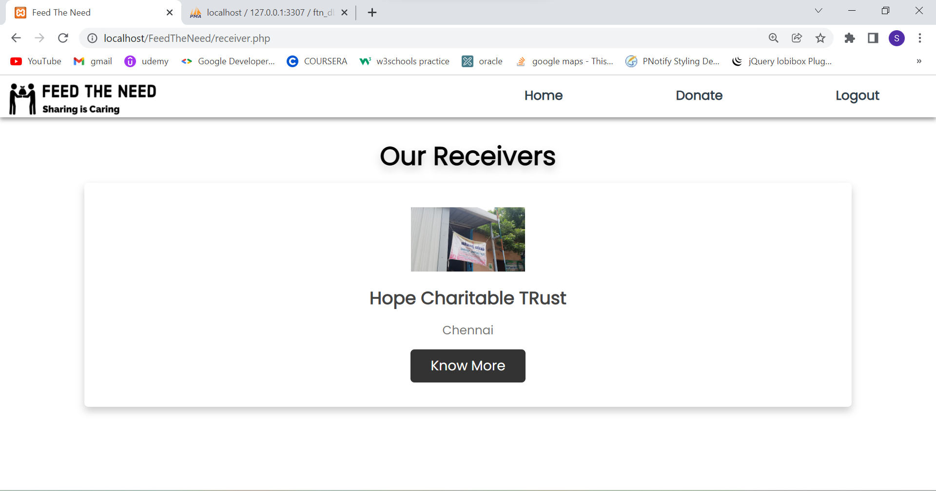

**Fig 6.6 RECEIVERS PAGE -** The list of receivers will be displayed in this page.

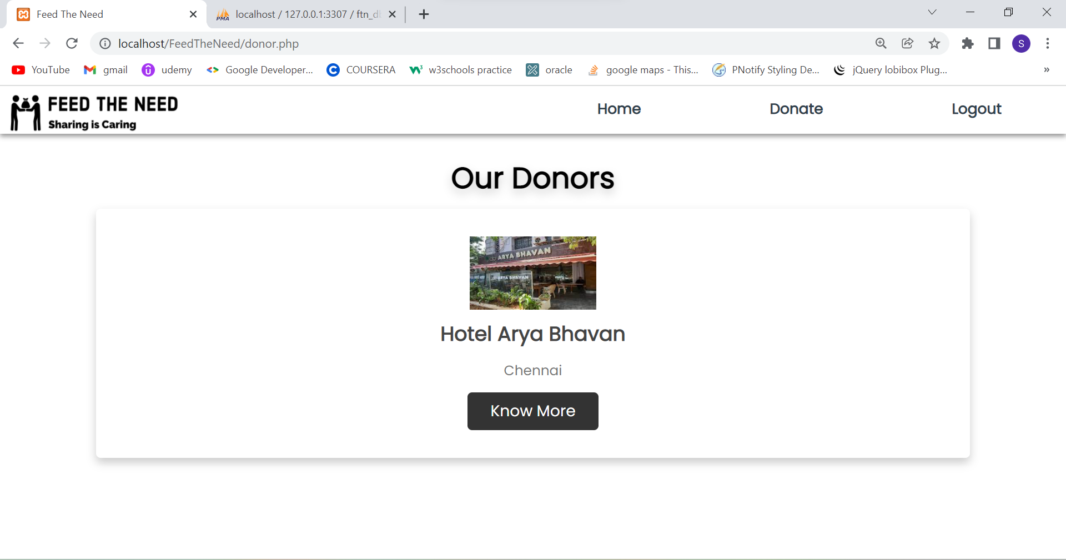

**Fig 6.7 DONOR PAGE -** The list of donors will be displayed in this page.

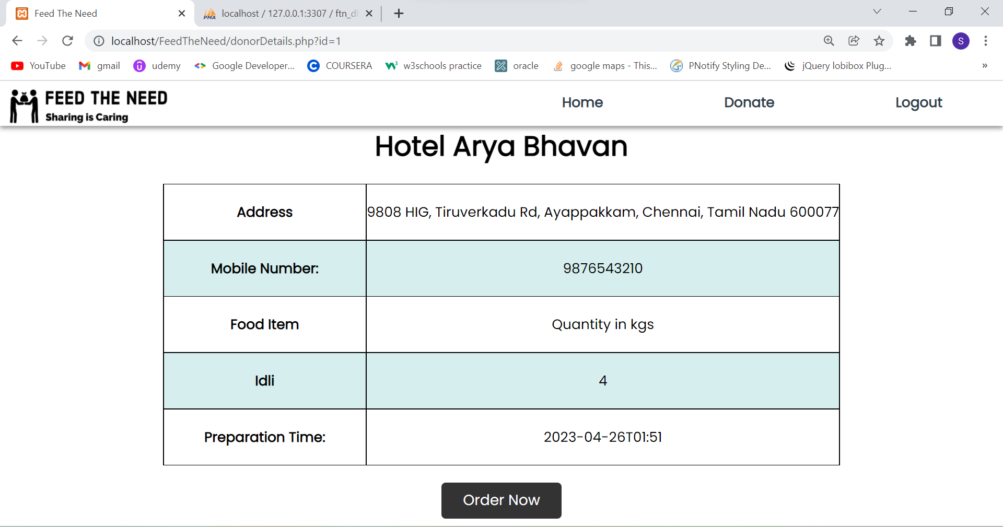

**Fig 6.8 DONOR DETAILS PAGE -** The details of the donor, details of the food item and their quantity will be displayed in this page.

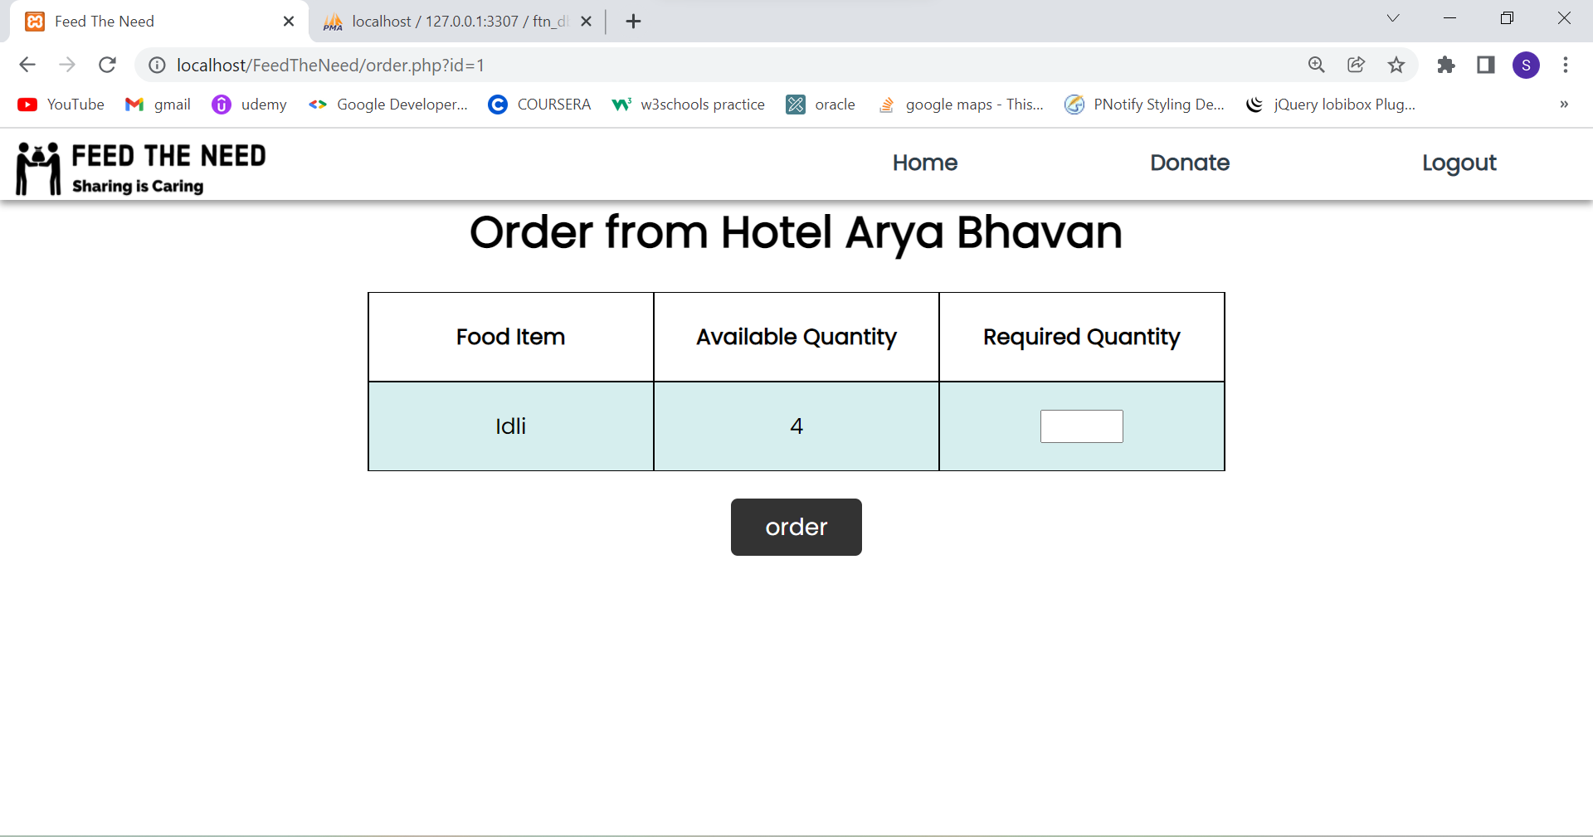

**Fig 6.9 ORDER PAGE** - The receiver can enter the quantity of food they want and order it.

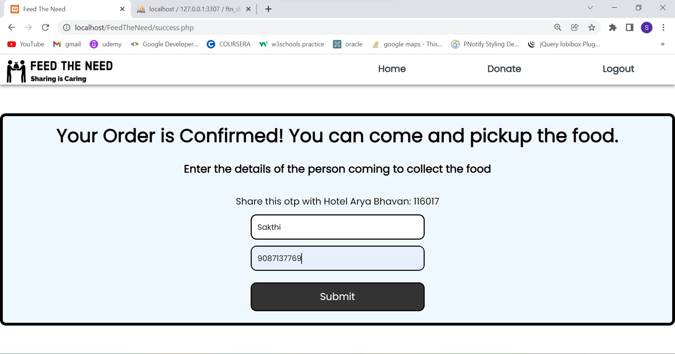

**Fig 6.10 CONFIRMATION PAGE -** After ordering the food, OTP will be sent to both deliverer and receiver to uniquely identify the receiver who is coming to collect the food. The details of the receiver and OTP will be sent as an email to the donor.

**CHAPTER 8**

**CONCLUSION AND FUTURE ENHANCEMENT**

In the future, google map api and geocoding api will be embedded so that it is easier to track the donor and receiver's location. Using this api, when the user enters the address, we can easily find out the latitude and longitude. In the future, delivery service will also be provided. It will be very useful to the receivers who cannot go and collect the food from the donor.

In the future, scheduled deliveries can be arranged between donors and receivers if they wish.

**REFERENCES**

1. <https://www.w3schools.com/>
2. Haversine Formula - https://www.geeksforgeeks.org/haversine-formula-to-find-distance-between-two-points-on-a-sphere/
3. https://youtube.com/
4. maps.google.com